Daniel Beck

CMSC-350

August 31, 2020

1. UML Class Diagram

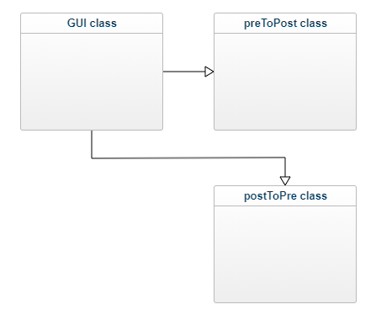

2. Test Cases

1. Test Postfix expression with all operators, with and without spaces
2. Test Prefix expression with all operators, with and without spaces
3. Error caught when invalid prefix expression is entered
4. Error caught when invalid postfix expression is entered

2a.

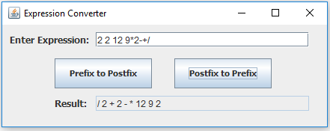

2b.

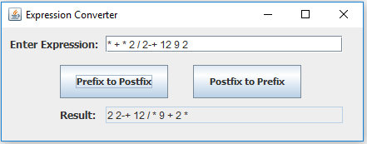

2c.

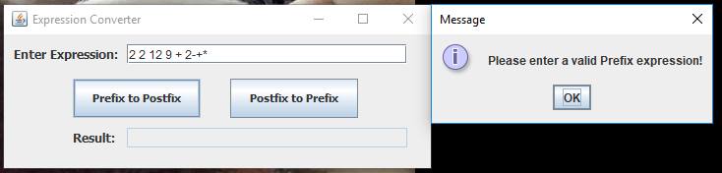

2d.

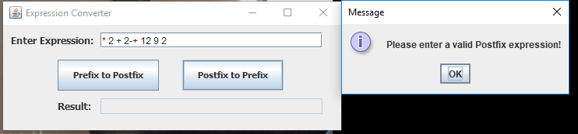

3. Lessons Learned

For this project, I learned a few new concepts of programming. The first being the algorithm of converting prefix and postfix expressions. I have never heard of these before this project, and while I still do not feel that I have fully grasped how they work, it is very interesting. The other key concept that I learned was the StringTokenizer. I never used this class before, but this project allowed me to see how useful they are.